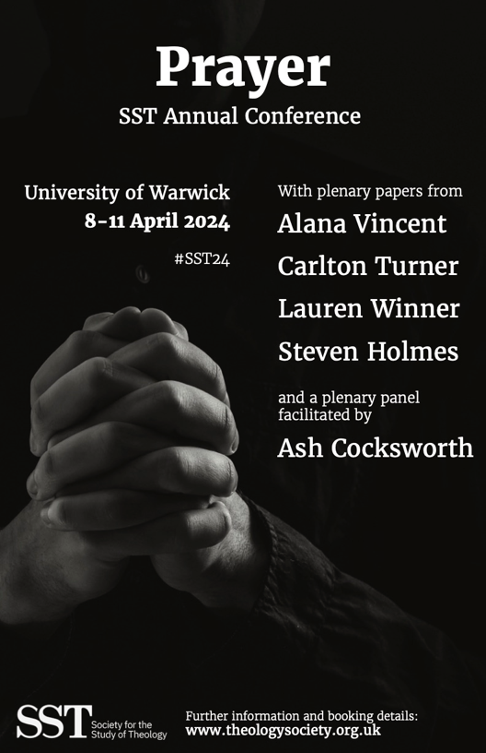
Access Pack: Contents
If additional information to that which has been included in this document would be helpful for you, please contact a member of the Accessibility Subcommittee, Nina Kurlberg or Rachel Noel, on nina.kurlberg@durham.ac.uk or rachel@thepinkvicar.com. SST is committed to increasing its inclusivity and we would value the opportunity to have a conversation with you.
If you would like to receive a printed copy of this access pack at the start of the conference, please contact the SST Secretary, Scott Midson, by 3rd April.

Key Dates p. 3
Map of Campus p. 4
Conference Venue: Ramphal Building p. 5
Conference Venue: Rootes Building p. 10
Conference Timetable p. 14

Key Dates

7th November 2023: Call for papers and bursaries opens
Early January 2024: Conference registration opens
17th January 2024: Deadline for receipt of paper proposals and bursary applications
16th February 2024: Notification of outcome
27th February 2024: Early booking rate closes
18th March 2024: Deadline for conference registration
Map of Campus
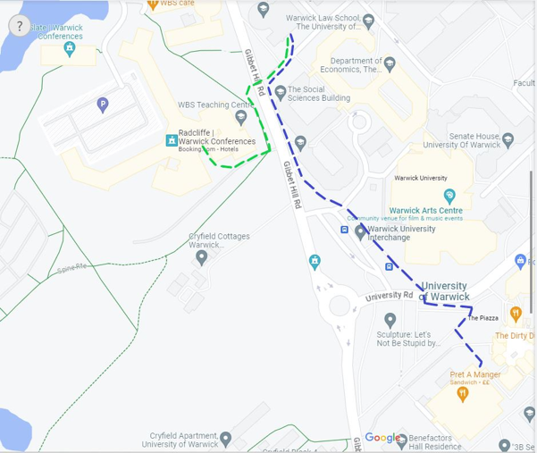
Please note that the blue and green routes shown on the above map are step-free routes from the Ramphal Building (located at the top centre of the map where the marked routes begin) to the Radcliffe and Rootes Buildings (the end of the blue route, where Pret A Manger is located).
Room keys can be collected from 2pm at Senate House. Senate House is located midway between the Ramphal and Rootes Buildings (on the right side of the above map).

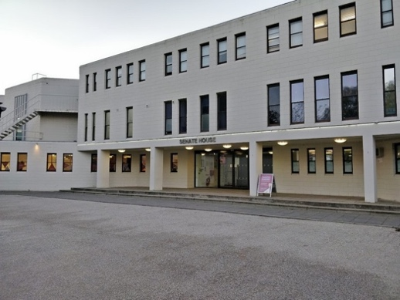
Source: https://uk.polomap.com/coventry/167255
Conference Venue: Ramphal Building
The conference will take place on the ground, first and second floors of the Ramphal Building.

Registration will be open from 4pm in the foyer of the Ramphal Building. On entering the building, you will see the registration desk on the lefthand side. There will be seating available in the foyer, and members of the SST Executive Committee will be there to welcome conference attendees and provide any information required.

Entrance to the Ramphal Building:
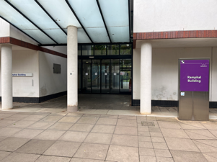
Plenary sessions will take place in the lecture theatre (R0.21).

Seminars will be spread across eight seminar rooms in the Ramphal Building: four on the ground floor (R0.03, R0.04, R0.12 and R0.14) and four on the first floor (R1.03, R1.04, R1.13 and R1.15). There is lift access between floors.

Ramphal Building directory:

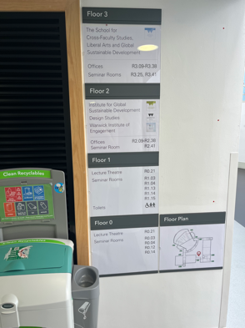
There is step-free access to the lecture theatre, all seminar rooms, and accessible toilets from the main entrance of the Ramphal Building, and this will be clearly signposted during the conference.

All rooms are connected to the hearing loop system, including the lecture theatre, and headsets are available on request for those who require them.

One of the seminar rooms on the second floor will be a designated quiet room for the duration of the conference.

Lecture theatre in the Ramphal Building:
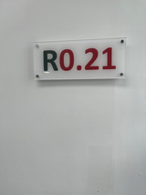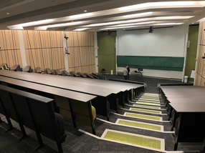
View from the front of the lecture theatre:
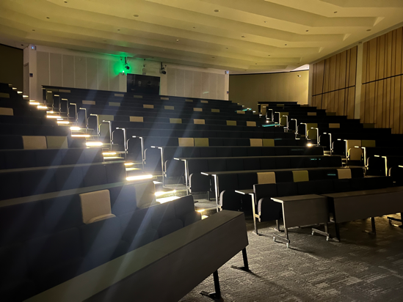
There is step-free access to the lecture theatre on both the ground and first floors, and this will be clearly signposted during the conference.
Ground floor seminar rooms in the Ramphal Building:
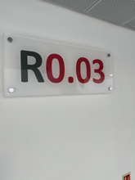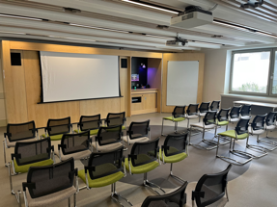
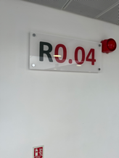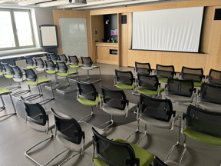
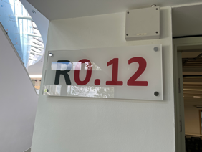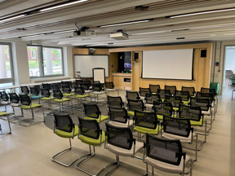
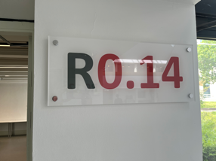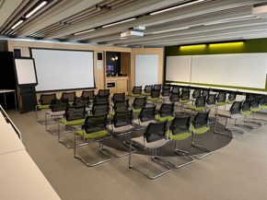
First floor seminar rooms in the Ramphal Building:

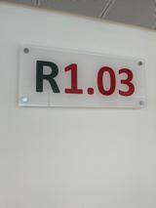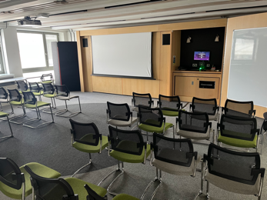

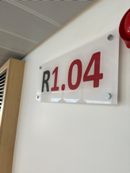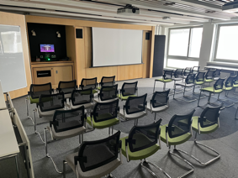

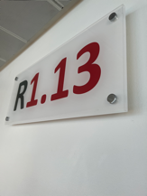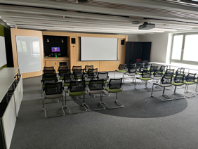

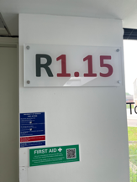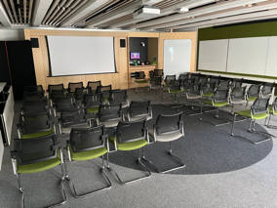

Accessible toilets are located on the first floor:
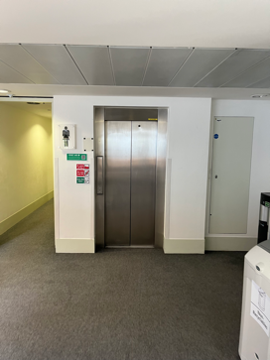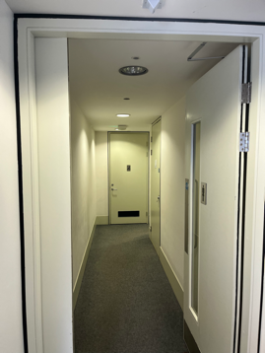

Conference Venue: Rootes Building
All meals will be served in the Rootes Restaurant, which is on the first floor of the Rootes Building. The step-free route to the Rootes Building is highlighted in blue on the campus map above (p. 4).
Please be advised that the Rootes Restaurant can be noisy during mealtimes. Early access to the dining room can be arranged on request.
Meals can only be confirmed at the start of the conference, but sample menus can be provided beforehand on request by contacting a member of the Accessibility Subcommittee.
Entrance to the Rootes Building:
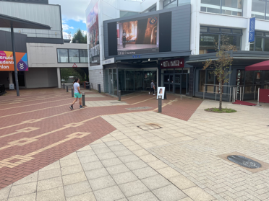
Sign for the lift to the Rootes Restaurant (floor 1) on entering the Rootes Building:
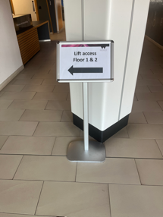

Stairs to the Rootes Restaurant:
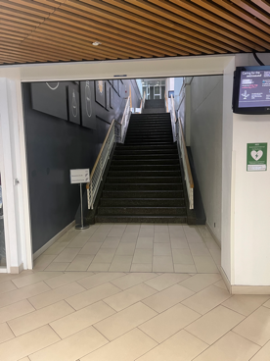
Top of the stairs / first floor lift:
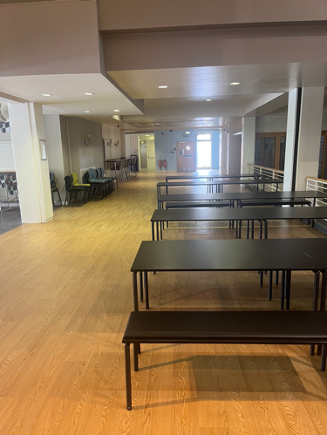
Entrance to the Rootes Restaurant:
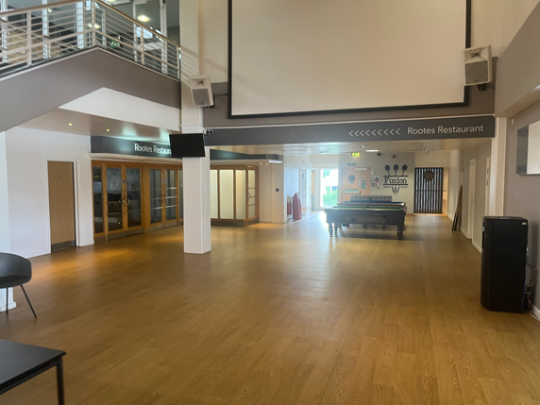
Inside the Rootes Restaurant (1):
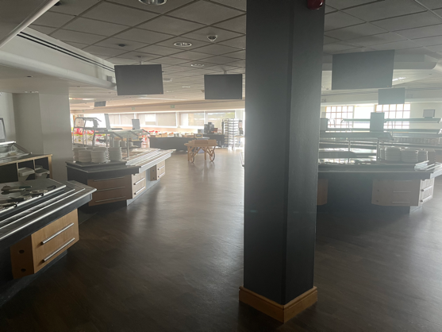
Inside the Rootes Restaurant (2):
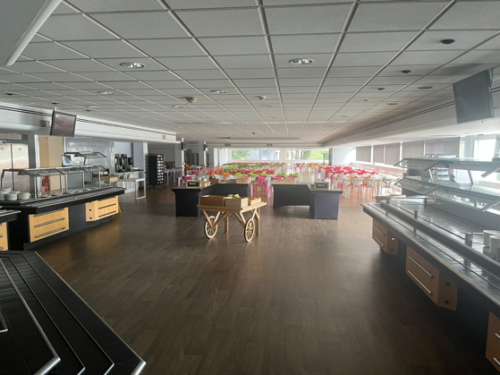

Conference Timetable
Monday 8th April
From 14:00 | Room key collection | Senate House
From 16:00 | Conference registration | Ramphal foyer
16:30 | First time attendees reception | Ramphal R0.03
17:00 | GMH scholars reception | Ramphal R0.04
17:30 | Opening reception (for all delegates) | Ramphal foyer
18:30 | Dinner | Rootes restaurant
19:50 | Welcome address (Prof David Clough, SST President) | Ramphal lecture theatre (R0.21)
20:00 | Plenary 1 | Ramphal lecture theatre (R0.21)
21:30-21:45 | Evening prayer
21:30 | Social time | TBC
Tuesday 9th April
07:30 | Breakfast | Rootes restaurant
08:30-08:45 | Morning prayer
09:00 | Plenary 2 | Ramphal lecture theatre (R0.21)
10:30 | Refreshments | Ramphal foyer
11:00 | Short papers 1; Seminar streams 1 | Ramphal rooms
13:00 | Lunch | Rootes restaurant
14:00 | Short papers 2 | Ramphal rooms
15:30 | Refreshments | Ramphal foyer
16:00 | Society AGM | Ramphal lecture theatre (R0.21)
17:30 | Women scholars reception | Ramphal R0.04
18:30 | Dinner | Rootes restaurant
20:00 | Plenary panel | Ramphal lecture theatre (R0.21)
21:30-21:45 | Evening prayer
21:30 | Social time | TBC
Wednesday 10th April
07:30 | Breakfast | Rootes restaurant
08:30-08:45 | Morning prayer
09:00 | Plenary 3 | Ramphal lecture theatre (R0.21)
10:30 | Refreshments | Ramphal foyer
11:00 | Short papers 3; Seminar streams 2 | Ramphal rooms
13:00 | Lunch | Rootes restaurant
14:00 | Meeting with SST President for postgraduate scholars | Ramphal lecture theatre (R0.21)
15:00 | Independent scholars reception | Ramphal R0.03
16:00 | Refreshments | Ramphal foyer
16:30 | Short papers 4 | Ramphal rooms
18:30 | Dinner | Rootes restaurant
20:00 | Plenary 4 | Ramphal lecture theatre (R0.21)
21:30-21:45 | Evening prayer
21:30 | Social time | TBC
Thursday 11th April
07:30 | Breakfast
09:30 | Check out for all delegates

